**Notes -- Crafting Quality Code -- LPT2**

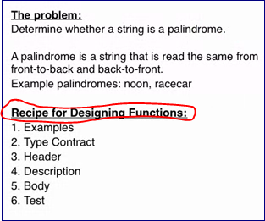

**Week2**

**Doc test.** Rather than running each example separately in the shell to test your function against the examples we may run them all at once.

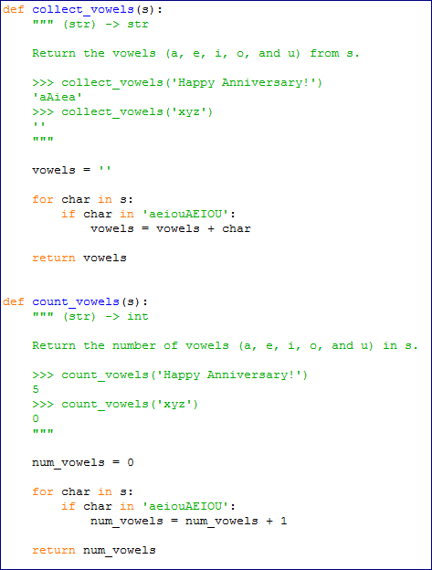

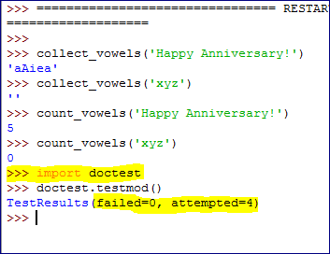

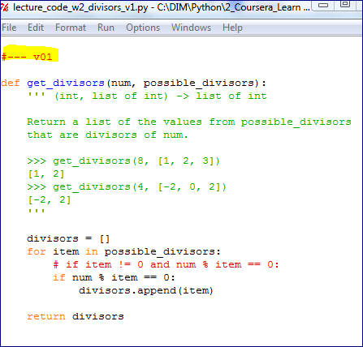

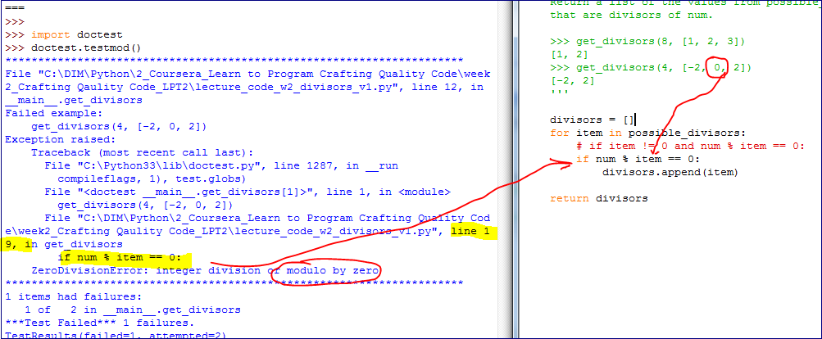

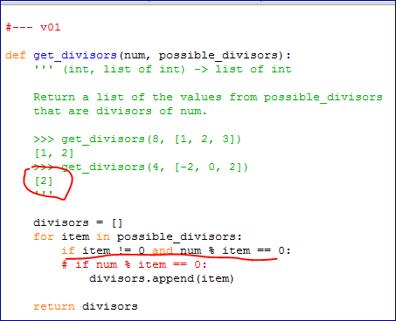

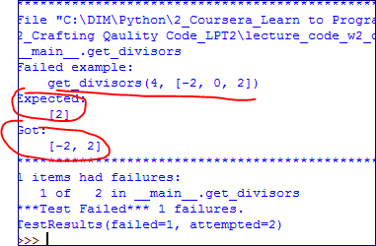

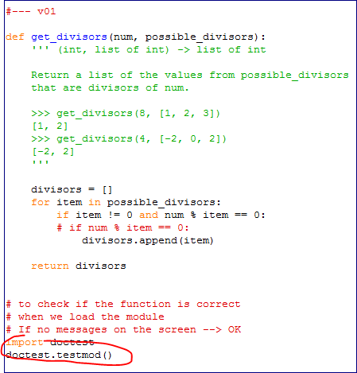

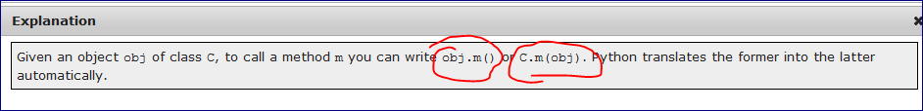

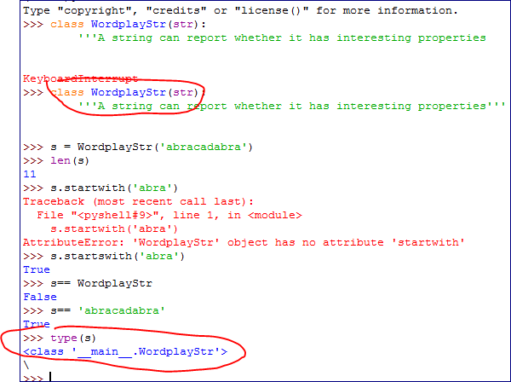

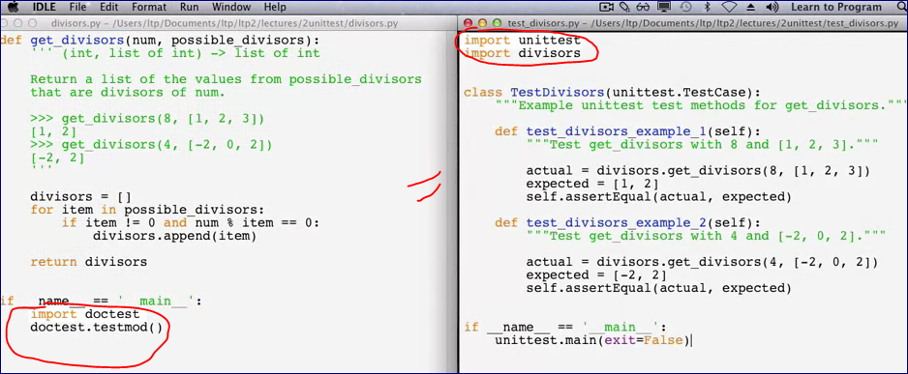

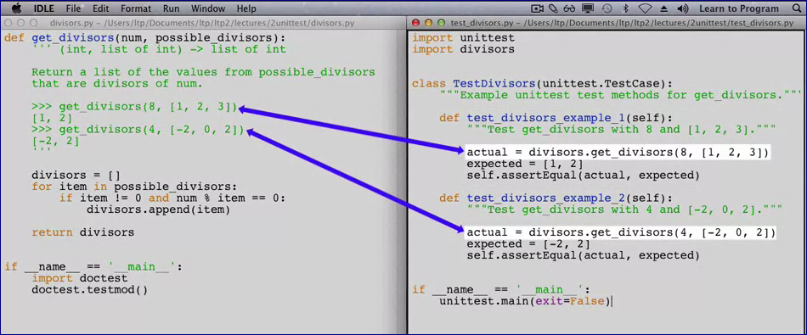

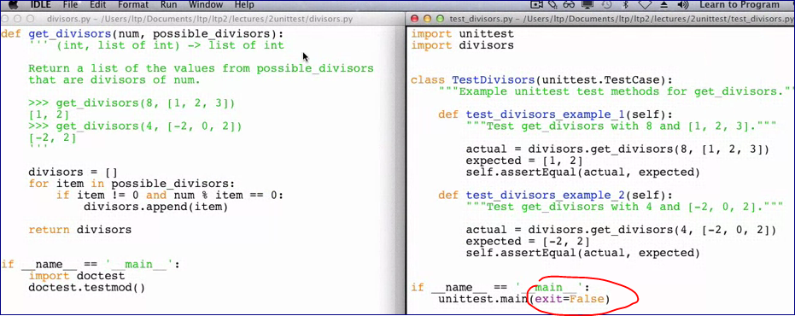

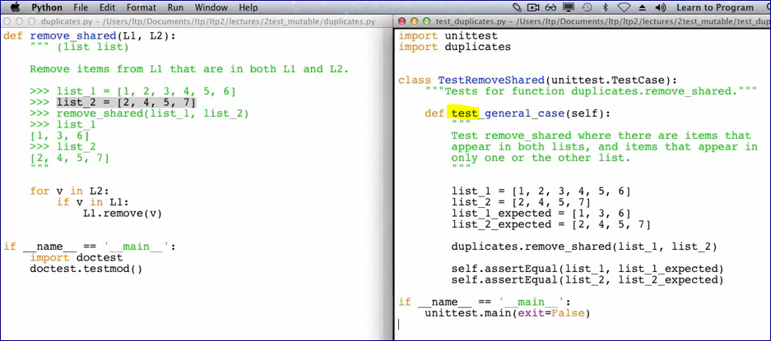

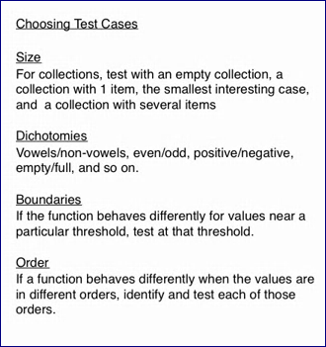

**Week4**

**Creating a New Type**

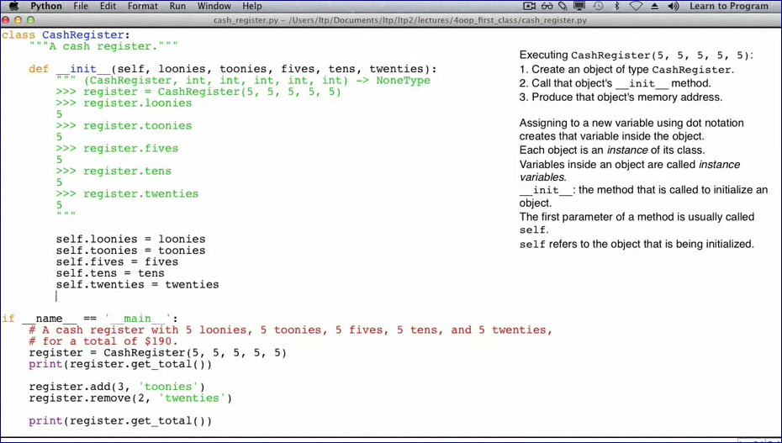

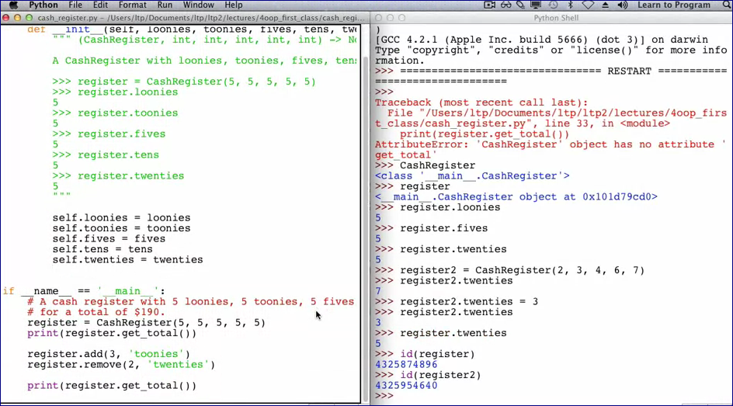

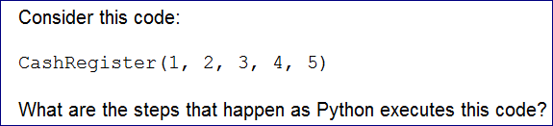

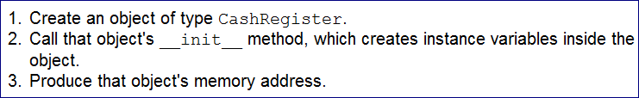

We created a class, an objects, and variables inside of the object.

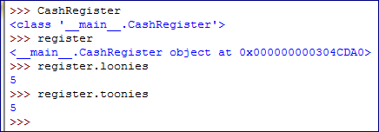

"register." shows the items inside of the object.

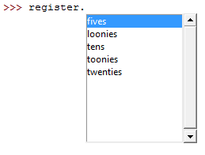

Let's create another object "register2"



New object also has all these variables

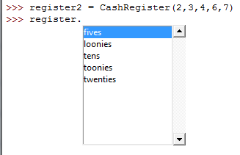

but with different values.



We can reassign the number of "twenties" in the 'register2' object

The number of 'twenties' in the first object stays the same

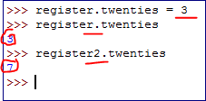

Because those two objects exist in different memory addresses

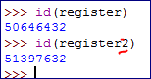

We got 190 from the get_total method but still have an error from the "add" method.

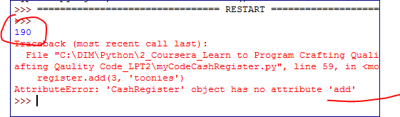

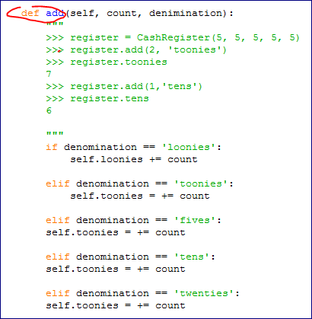

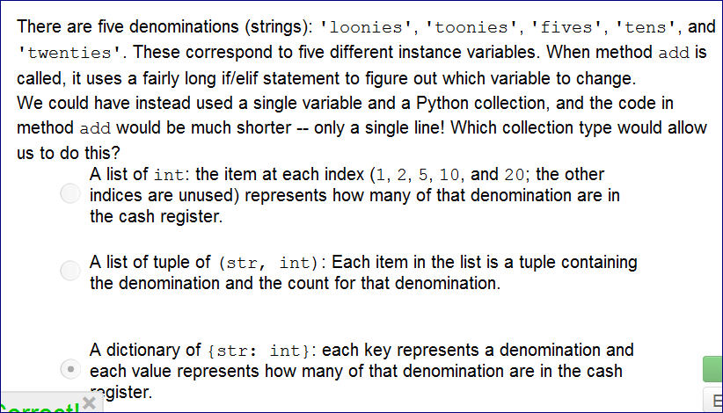

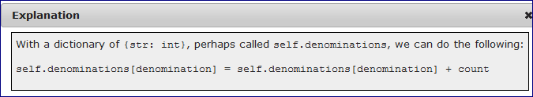

# Plugging Your Classes into Python Syntax

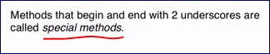

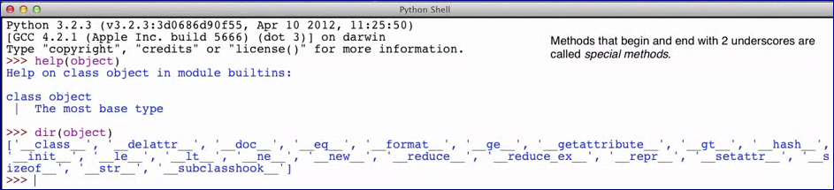

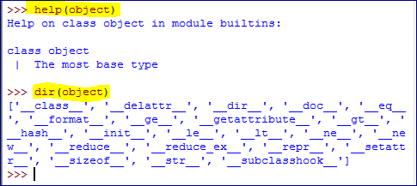

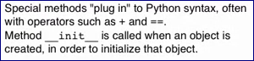

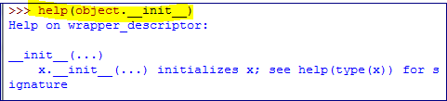

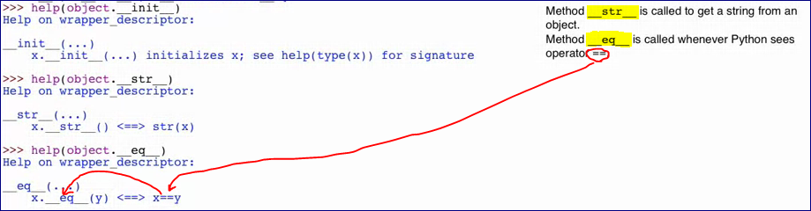

If we comment out our "compare" method

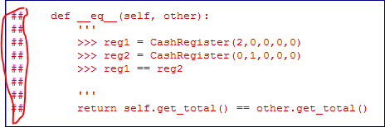

and run the program we get

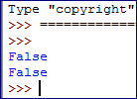

Because Python by default compares memory addresses for equality.

If no __methods defined in the class it uses objects __methods.

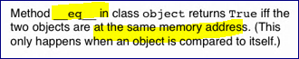

# Writing Special Method __str__

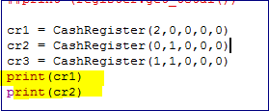

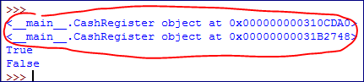

Because the function print() calls __str__ on the function it's printing

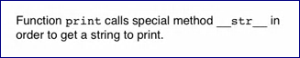

First solution:

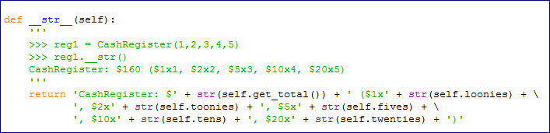





Another option is to use a **str.format** method.

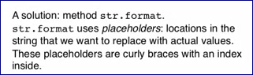

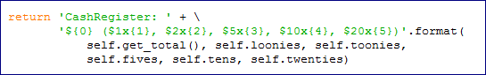



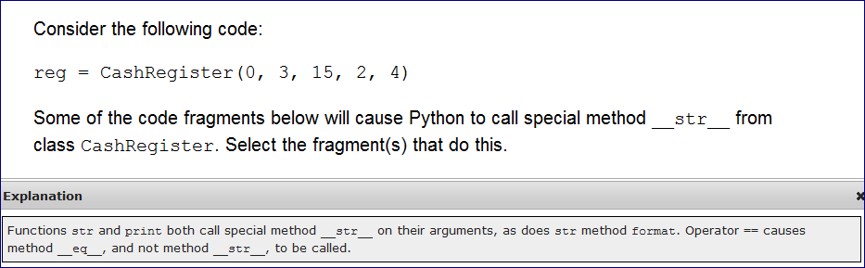

# Writing Classes That Interact

**Week5**

**Lecture 1 -- Passing functions as arguments**

Call a function from a function

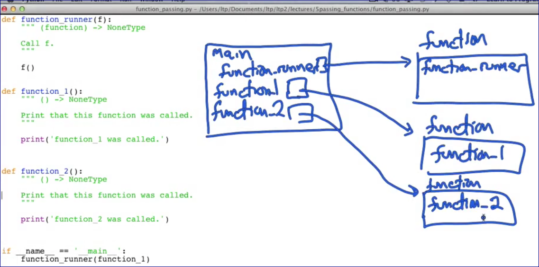

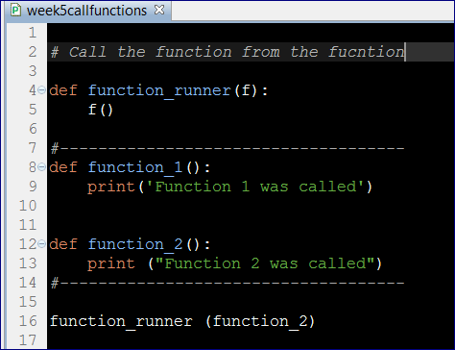

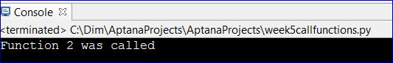

**Lecture 2 -- Assigning parameters default values**

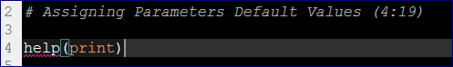

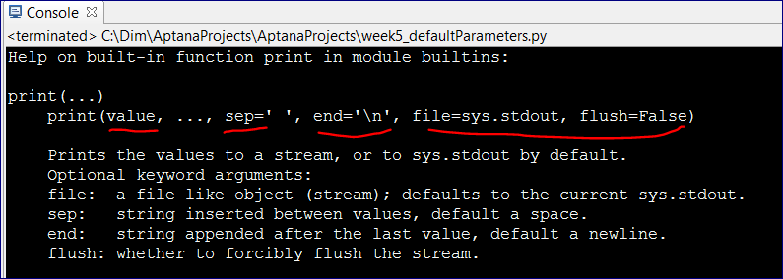

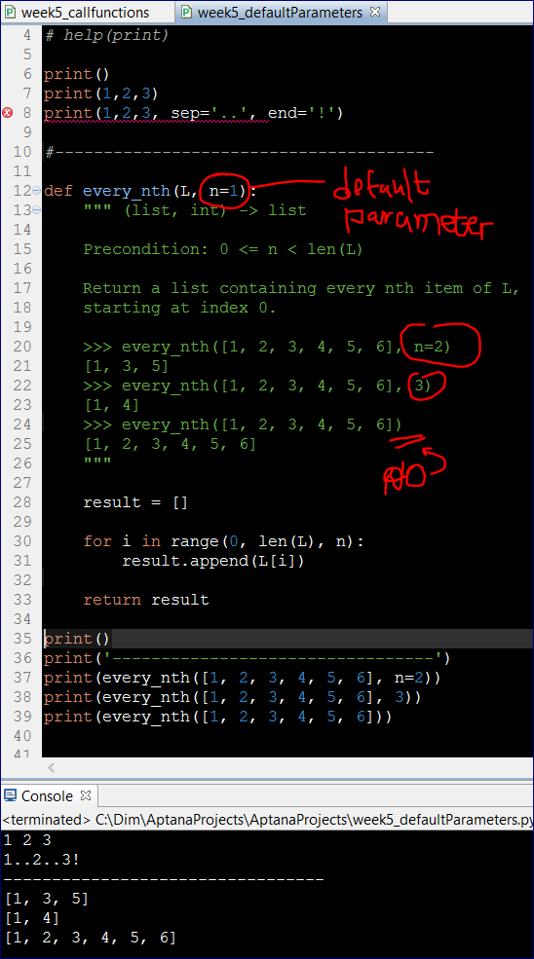

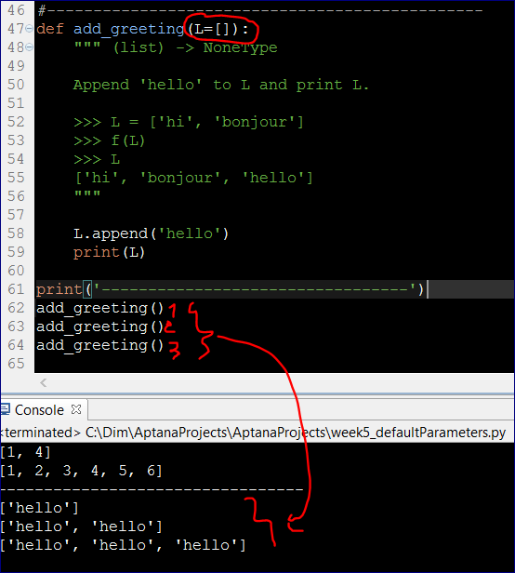

**Lecture 3 -- Dealing with Exceptional Situations (7:26)**

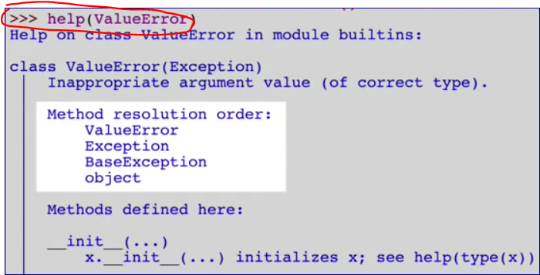

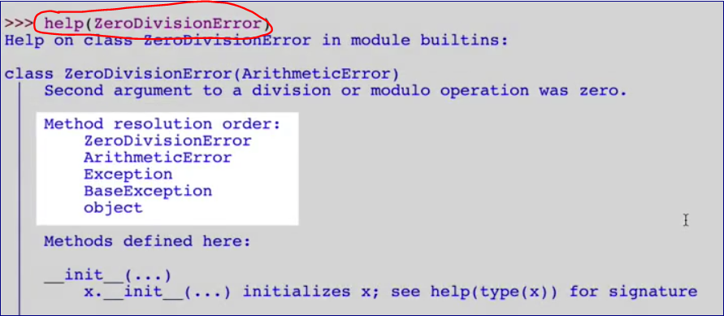

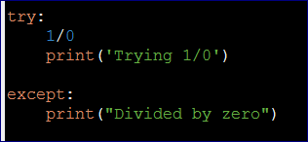

**We can specify what errors we want to catch**

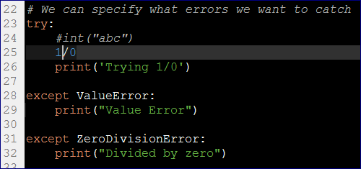

Every exception is an object and Python allows to give them names.

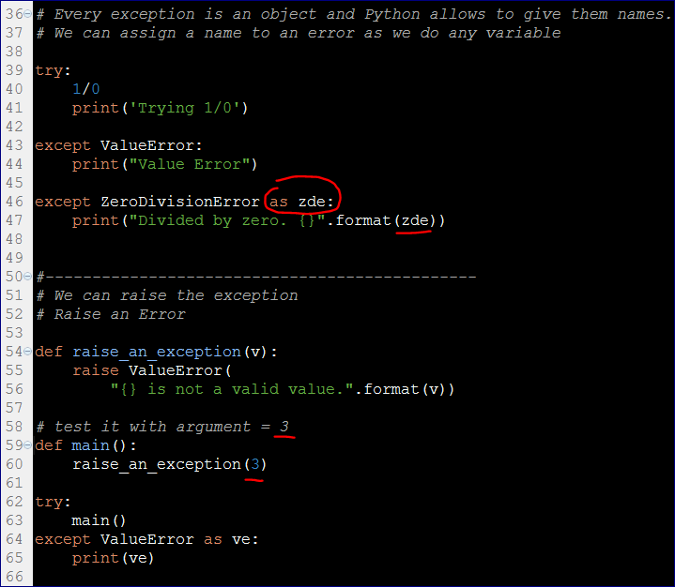

#----------------------------------------------

# Assert

#----------------------------------------------

x = 3

assert x == 3

# assert x == 4

# We can use an assert statement to check preconditions

# To make sure the function uses a valid argument

